# RECOMMENDATION ${REC}: INSTALL INDUSTRIAL FANS TO IMPROVE AIR CIRCULATION

### Recommended Action

Install large industrial fans in the production area to improve air circulation.

**Summary of Estimated Savings and Implementation Costs**

|  |  |
| --- | --- |
| Annual Cost Savings | ${ACS} |
| Implementation Cost | ${IC} |
| Payback Period | ${PB} |
| Annual Natural Gas Savings | ${NGS} MMBtu |
| Annual Electricity Savings | ${ES} kWh |
| Annual Demand Savings | ${DS} kW |
| ARC Number | 2.7312.3 |

**Current Practice and Observations**

Currently, the plant does not have any fans installed to allow for proper air circulation throughout the production area. Therefore, the heating system operates inefficiently during winter, and there is poor ventilation during the summer. As cold air is denser than hot air, it settles on the working layer, and the hot air floats up to the ceiling, which causes the heating system to run at a higher load to supply a comfortable working environment. Destratification fans can be used to pull the air from the ceiling level down to the floor level and allow it to mix with cooler air to increase the temperature at the working level. This will reduce the energy use of the heating system. In addition, these destratification fans can replace multiple small fans that are currently being used in the facility during summer time.

A recent computational fluid dynamics, CFD, study, performed by the Building Services Research and Information Association (BSRIA), quantified percentage energy savings by destratification fans as a function of ceiling height and measured stratification (temperature difference between the floor and the ceiling). Figure below shows the percentage energy savings as a function of stratification temperature and ceiling height.

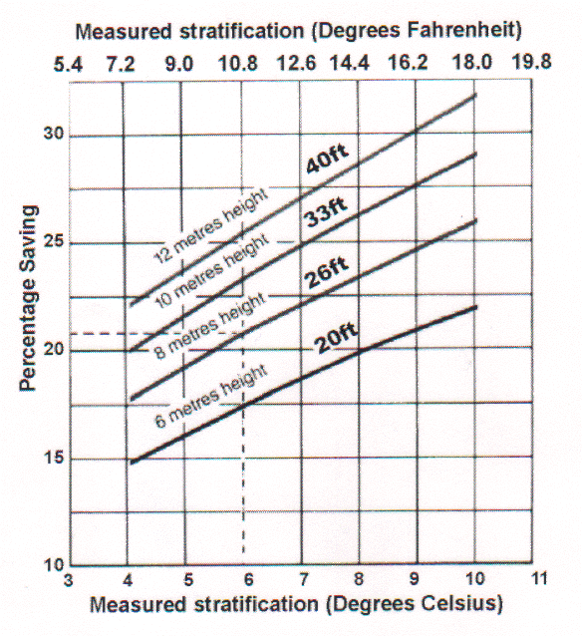

**Figure 1:** **The percentage energy savings as a function of stratification temperature and ceiling height.**

**Anticipated Savings**

An estimate of the savings which could be realized through installation of the large fans can be made by using the following approach. It is recommended to initially install ${FANStr} ${DIA} ft. diameter industrial fans to cover the entire operating area.

The natural gas nergy savings, NGS, is calculated as follows:

NGS = PR × NGU

where,

PR = Percent of reduction in natural gas consumption (conservatively assumed to be ${PR}%/yr)

NGU = Anuual natural gas usage for heating, MMBtu/yr (estimated: ${NGU} MMBtu/yr).

NGS= ${PR}% × ${NGU} MMBtu/yr

= ${NGS} MMBtu/yr

The extra electricity consumption, ES is calculated as :

ES = -N × HP × C1 × OH

where,

N = Number of proposed fans: ${FAN}

HP = Horsepower of proposed fans: ${HP} HP

C1 = Conversion constant: 0.7457 kW/HP

OH = Operating hours of existing fans, ${OH} hrs/yr. (${HR} hrs/day, ${DY} days/wk, ${WK} wks/yr)

ES = -${FAN} × ${HP} HP × 0.7457 kW/HP × ${OH} hrs/yr

= ${ES} kWh/yr

The extra demand consumption, DS, is evaluated as follow:

DS = -N × HP × C1 × 6 mo/yr × CF

where,

CF = Coincedence factor: 100%/mo

DS = - ${FAN} × ${HP} HP × 0.7457 kW/HP × 6 mo/yr × 100%/mo

= ${DS} kW/yr

The total annual cost saving, ACS, is:

ACS = NGS × natural gas cost + ES × electricity cost + DS × demand cost

= ${NGS} MMBtu/yr × ${NGC}/MMBtu – ${ES} kWh/yr × ${EC}/kWh – ${DS} kW × ${DC}/kW

= ${NGCS}/yr – ${ECS}/yr – ${DCS}/yr

= ${ACS}/yr

**Implementation Cost**

Based on a price of ${COST} each industrial fan including installation, The implementation cost of ${FAN} industrial fans is about ${IC}.

<REBATE>

However, there could be energy efficiency rebates available through your utility company, which could potentially reduce the overall capital cost and thereby the payback period. The savings from the rebate is calculated below.

RB = ${ERR}⋅yr/kWh × ES

= ${ERR}⋅yr/kWh × ${ES} kWh/yr

= ${RB}

The incentives are capped at 50% of the project cost, which makes the modified rebate savings, MRB, equal to ${MRB}. Hence, the modified implementation cost, MIC, is estimated as follows:

MIC = IC - MRB

= ${IC} - ${MRB}

= ${MIC}

The modified implementation cost is ${MIC}.</REBATE>

**The annual natural gas savings for this AR would be ${NGS} MMbtu. The annual electricity savings is ${ES} kWh and the annual demand savings is ${DS} kW. The estimated annual cost savings is ${ACS} and, with an implementation cost of about ${IC}, the payback period would be about ${PB}.**

**Implementation Cost References:**

The below links are for implementation cost references. We do not endorse/recommend these brands or products. Furthermore, these products may or may not be suitable for the application. The client should contact a vendor(s) to conduct a detailed study of the process, in order to determine the best product for the recommended application.

* <https://store.bigassfans.com/en_us/shopfan>
* <https://www.northerntool.com/shop/tools/category_fans+big-ass-fans?seeAll=1>